

DATA STRUCTURES AND ALGORITHM
23CSE203
LAB MANUAL
SUBMITTED BY
NAME | GOVADA NEHA BHAVANI
ROLL NO | AV.SC.U4CSE25031
YEAR/SEM/SECTION | 2nd YEAR /SEM-3/CSE A
CREDITS | 05

SUBMITTED TO | DR. RAJ KUMAR BATCHU
DESIGNATION | ASST.PROFFESSOR (Sl. Grade)
DEPARTMENT | SCHOOL OF COMPUTING

INDEX
S.NO | TITLE | PAGE NO | REMARKS
1. | WEEK-1:1a. Recursive countdown from n to Launch.  1b. Recursive calculation of compound growth factor.  1c. Recursive search for employee ID in list.  1d. Recursive factorial calculation for parcel arrangements.  1e. Recursive Fibonacci series generation. | 3-12
2. | WEEK-2: 2a. Python program to perform linear search on the given input.  2b. Python program to perform binary search on the given input.  2c. Verify by taking sorted array and unsorted array as an input. | 13-18
3. | WEEK -3: 3a. Python program to perform bubble sort on the given input.  3b. Python program to perform insertion sort on the given input.  3c. Python program to perform selection sort on the given input.  3d. Python program to perform merge sort on the given input.  3e. Python program to perform quick sort on the given input. | 19-27
4. | WEEK-4: 4a. Write the python program to implement a single linked list which could perform the below operations,by taking an input from the user.  4b. Write the python program to implement a double linked list which could perform the below operations,by taking an input from the user.  4c. Write the python program to implement a circular linked list which could perform the below operations,by taking an input from the user. | 28-46
5. | WEEK-5:Write a python program to implement a stack using an Array, Linked list. Implement the stack operations such as push, pop, peak and also display the stack elements | 47-51
6. | WEEK-6: 6a. Write a python program to implement queue and its operations such as enqueue, dequeue, peek, display with a menu driven approach implement using array, linked list.  6b. Write a python program to implement queue and its operations such as enqueue, dequeue, peek, display with a menu driven approach implement using circular linked list. | 52-59
7. | WEEK-7: 7. Write a program to implement a binary tree using an array and linked list with all of its operation. | 60-67
8. | WEEK-8: 8. Write a python program to implement Binary Search Trees with its operations. | 68-72
9. | WEEK-9: 9. Write a python program to implement AVL trees with its operation. | 73-78

WEEK-1
AIM: 1a. A rocket launch system displays a countdown before the launch. Instead of using a loop, implement the countdown using recursion. Write a recursion python program to display countdown from n to 1, followed by “Launch”.
Program:
def countdown(n):
if n <= 0:
print("Launch")
return
print(n)
countdown(n - 1)
n = int(input("Enter the countdown number: "))
countdown(n)
Output:
Positive Case:
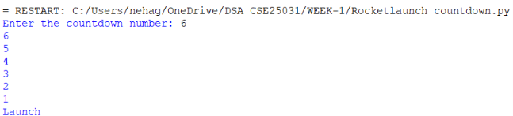
Negative Case:
Explanation:
def countdown(n):
- Defines a recursive function named countdown.
if n <= 0:
- n <= 0 → Checks whether n is less than or equal to 0.

countdown(n - 1)
- Calls the same function again with n - 1.
- The function keeps calling itself until n becomes 0.
n = int(input("Enter the countdown number: "))
- Accepts the starting number from the user.
countdown(n)
- Calls the countdown() function to start the recursive countdown.

Error Table:
S.NO | Error Obtained | Rectification
1. | Indentation Error: expected an indented block. | Corrected the indentation(used proper spaces/tabs).
2. | Syntax Error: invalid  Syntax. | Missing brackets.
3. | Value Error: invalid literal for int( ) | Entered a valid integer as input.

AIM: 1b. Banks calculate the growth of an investment using compound interest. The formula requires calculating powers, which can be implemented recursively. Write a recursive program to calculate p(power n), where: p = principle growth factor, n = number of years.
Program:
def power(p, n):
if n == 0:
return 1
elif n > 0:
return p * power(p, n - 1)
else:
return 1 / power(p, -n)
p = float(input("Enter the principal growth factor (p): "))
n = int(input("Enter the number of years (n): "))
result = power(p, n)
print("Result =", result)
Output:
Positive Case:
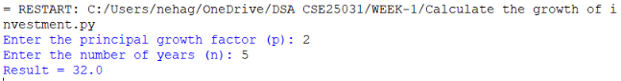
Negative Case:
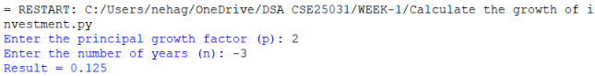
Explanation:
def power(p, n):
- power → Name of the function.
- p → Principal growth factor (base).
- n → Number of years (power/exponent).
if n == 0:
- Checks whether n is equal to 0.
- This is the base case of the recursion.

elif n > 0:
- Checks if the exponent (n) is positive.
return p * power(p, n - 1)
- Multiplies p by the result of power(p, n-1).
- This is the recursive call.
- The function keeps calling itself until n becomes 0.
else:
- Executes when n is negative.
return 1 / power(p, -n)
- Converts the negative exponent into a positive exponent using -n.
- Finds the power and returns its reciprocal.
p = float(input("Enter the principal growth factor (p): "))
- input() → Accepts the base value from the user.
- float() → Converts the input into a decimal number.
n = int(input("Enter the number of years (n): "))
- Accepts the exponent (n) from the user.
- • int() converts the input into an integer.
Error Table:
S.NO | Error Obtained | Rectification
1. | Indentation Error: expected an indented block. | Corrected the indentation by using proper spaces/tabs.
2. | Syntax Error: invalid  Syntax. | Missing brackets.
3. | Zero Division Error: division by zero (when p = 0 and n is negative) | Used a non-zero value for p when n is negative, or added a condition to prevent division by zero.

AIM: 1c. An HR department stores employee ID’s in a list. Develop a recursive program to search for a given employee ID. Write a recursive function to search for an employee ID in a list.
Program:
def search(emp, key, index):
if index == len(emp):
return False
if emp[index] == key:
return True
return search(emp, key, index + 1)
emp = [101, 102, 103, 104, 105]
key = int(input("Enter Employee ID to search: "))
if search(emp, key, 0):
print("Employee ID Found")
else:
print("Employee ID Not Found")

Output:
Positive Case:
Negative Case:

Explanation:
def search(emp, key, index):
- def – Used to define a function.
if index == len(emp):
- Checks whether the index has reached the end of the list.
return False
- Returns False because the employee ID is not found.
if emp[index] == key:
- Compares the current employee ID with the ID entered by the user.
return search(emp, key, index + 1)
- Calls the same function again with the next index.
- The search continues until the ID is found or the end of the list is reached.
emp = [101, 102, 103, 104, 105]
- Creates a list of employee IDs.
if search(emp, key, 0):
- Calls the search() function.
- Starts searching from index 0.
Error Table:
S.NO | Error Obtained | Rectification
1. | Indentation Error: expected an indented block. | Corrected the indentation by using proper spaces/tabs.
2. | Syntax Error: invalid  Syntax. | Missing brackets.
3. | IndexError: list index out of range | Added the base condition if index == len(emp): before accessing emp[index].

AIM: 1d. In a logistics company, the number of possible ways to arrange n different parcels is calculated using the factorial formula (n!). Develop a recursive program to calculate the factorial of a given number.
Program:
def factorial(n):
if n == 0 or n == 1:
return 1
elif n > 1:
return n * factorial(n - 1)
else:
return "Factorial not defined for negative numbers"
n = int(input("Enter a number: "))
result = factorial(n)
print("Factorial =", result)

Output:
Positive Case:
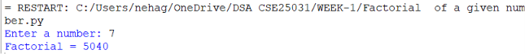
Negative Case:
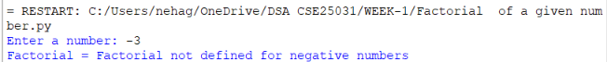

Explanation:
This program calculates the factorial of a number using iteration (not recursion).
Error Table:
S.NO | Error Obtained | Rectification
1. | Over Flow/Large input: Large value | Give smaller input
2. | Syntax Error: invalid  Syntax. | Missing brackets.

AIM: 1e. Write a recursive python program to print the first n terms of the Fibnocci Series.
Program:
def fibonacci(n):
if n <= 1:
return n
return fibonacci(n - 1) + fibonacci(n - 2)
n = int(input("Enter the number of terms: "))
if n <= 0:
print("Enter a positive number")
else:
for i in range(n):
print(fibonacci(i), end=" ")
Output:
Positive Case:

Negative Case:

Explanation:
The program uses recursion to generate Fibonacci numbers. fib(0)=0 and f(1)=1 are the base cases. For every other term, fib(n)=fib(n-1)+fib(n-2). The loop prints the first n terms.

Error Table:
S.NO | Error Obtained | Rectification
1. | Recursion Error: Large value of n | Use iteration
2. | Invalid input: Negative value of n | Validate input
3. | Slow execution: Repeated recursive calls. | Use dynamic programming.

PROGRAM | TIME COMPLEXITY | SPACE COMPLEXITY | REASON
1.countdown to launch |  |  | The program uses a loop that prints from n to 0 once.
  O(n)
  O(1)
2.power calculation |  |  | One recursive call is made for each value of n. The recursion stack stores n calls.
  O(n)
  O(n)
3.employee ID search |  |  | The program performs a linear search through the list.
  O(n)
  O(1)
4.Factorial |  |  | The program calculates factorial using a loop from 1 to n.
  O(n)
  O(1)
5.Fibonacci series
  O(2ⁿ)
  O(n)
  Each function call creates two more recursive calls, leading to exponential time. The recursion stack reaches depth n.

WEEK-2

AIM: 2a. Write a python to perform linear search on the given input.
Program:
def linear_search(arr,key):
for i in range(len(arr)):
if arr[i] == key:
return i
return -1
n = int(input("Enter the number of elements:"))
arr = []
print("Enter elements in order:")
for i in range(n):
arr.append(int(input()))
key = int(input("Enter the element to search:"))
result = linear_search(arr,key)
if result!=-1:
print(f"Element found at index {result}")
else:
print("Element not found")
Output:
Positive Case:
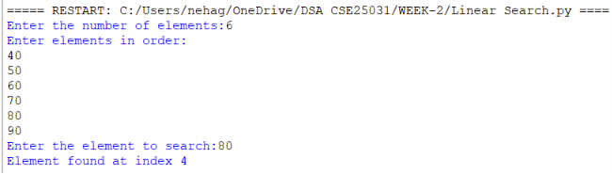
Negative Case:
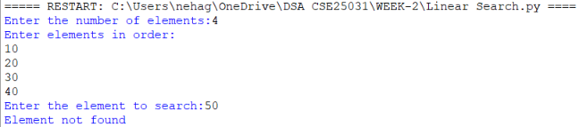
Explanation:
This program performs a linear search to find a given element in a list. First, it takes the number of elements and stores them in an array. Then, the user enters the element to be searched. The linear_search() function compares the key with each element one by one. If the element is found, it returns its index; otherwise, it returns -1. Finally, the program displays whether the element was found and its index or shows "Element not found".
Error Table:
S.NO | Error Obtained | Rectification
1. | ValueError: Entering a non-integer value. | Enter only numbers.
2. | Invalid input: Negative value of n | Validate input
3. | Wrong output: Searching for an element not in the list. | Enter an element that exists in the list.

AIM: 2b. Write a python program to perform binary search on the given input. Verify by taking sorted array and unsorted array.
Program:
Sorted List:
def binary_search(arr,key):
low = 0
high = len(arr) - 1
while low <= high:
mid = (low + high) // 2
if arr[mid] == key:
return mid
elif arr[mid] < key:
low = mid + 1
else:
high = mid - 1
return -1
n = int(input("Enter the number of elements:"))
arr = []
print("Enter elements in sorted order:")
for i in range(n):
arr.append(int(input()))
key = int(input("Enter the element to search:"))
result = binary_search(arr,key)
if result != -1:
print(f"Element found at index {result}")
else:
print("Element not found")
Unsorted List:
def binary_search(arr,key):
low = 0
high = len(arr) - 1
while low <= high:
mid = (low + high) // 2
if arr[mid] == key:
return mid
elif arr[mid] < key:
low = mid + 1
else:
high = mid - 1
return -1
n = int(input("Enter the number of elements:"))
arr = []
print("Enter elements in sorted order:")
for i in range(n):
arr.append(int(input()))
key = int(input("Enter the element to search:"))

if arr == sorted(arr):
print("The input list is already sorted.")
else:
print("The input list is not sorted.")
print("The list is sorting...")
arr.sort()
print(f"Sorted list: {arr}")

result = binary_search(arr,key)
if result != -1:
print(f"Element found at index {result}")
else:
print("Element not found")
Output:
Sorted List:
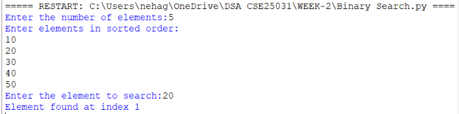

Unsorted List:
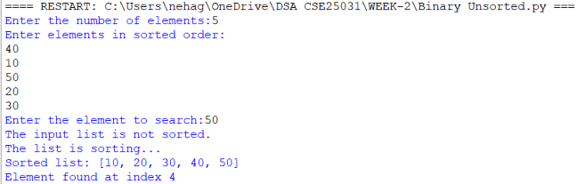

Explanation:
Sorted List:
This program checks whether the given list is sorted. If it is unsorted, the program sorts it using arr.sort(). Then, binary search is performed by checking the middle element and reducing the search range. Finally, it displays the index if the element is found; otherwise, it prints "Element not found."
Unsorted List:
This program accepts an unsorted list from the user and checks whether it is sorted. If the list is unsorted, it sorts the elements using arr.sort(). After sorting, the program uses binary search to find the required element and displays its index if found; otherwise, it prints "Element not found."
Error Table:
S.NO | Error Obtained | Rectification
1. | ValueError: Entering non-numeric values | Enter only numbers.
2. | Invalid input: Negative value of n | Validate input
3. | Wrong search result:  List is not found before binary search. | Use arr.sort( ) before searching.

PROGRAM | TIME COMPLEXITY | SPACE COMPLEXITY | REASON
1.Linear Search |  |  | Checks each element one by one.
  O(n)
  O(1)
2.Binary Search(Sorted List) |  |  | Divides the search range into half each time.
  O(log n)
  O(1)
3.Binary Search(Unsorted List) |  |  | First sorts the list in O(n log n) in Python, then performs binary search in O(log n).
  O(n+log n)
  O(1)

WEEK-3

AIM: 3a. Write a python program to sort the elements using a bubble sort technique. Take the input elements from the user.
Program:
n = int(input("Enter the number of elements: "))
arr = []
print("Enter the elements:")
for i in range(n):
arr.append(int(input()))
for i in range(n - 1):
for j in range(n - i - 1):
if arr[j] < arr[j + 1]:
arr[j], arr[j + 1] = arr[j + 1], arr[j]
print("Elements after Bubble Sort:")
print(arr)
Output:
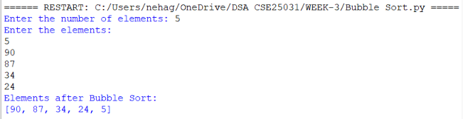
Explanation:
• n = int(input(...)) – Gets the number of elements.
• arr = [] – Creates an empty list to store elements.
• for i in range(n) – Takes n elements as input.
• arr.append(...) – Adds each element to arr.
• for i in range(n - 1) – Performs Bubble Sort passes.
• for j in range(n - i - 1) – Compares adjacent elements.
• if arr[j] < arr[j + 1] – Checks if the current element is smaller.
• arr[j], arr[j + 1] = ... – Swaps the elements to sort in descending order.
• print(arr) – Displays the sorted list.
Error Table:
S.NO | Error Obtained | Rectification
1. | Sorting Order Error – Using > instead of < in the if condition changes the order to ascending. | Use if arr[j] < arr[j + 1]: for descending order.

AIM: 3b.Write a python program to sort the elements using a insertion sort technique. Take the input elements from the user.
Program:
def insertion_sort(arr):
n = len(arr)
for i in range (1,n):
key = arr[i]
j = i - 1
while j >= 0 and arr[j] > key:
arr[j+1] = arr[j]
j = j - 1
arr[j+1] = key
return arr
n = int(input("Enter the number of elements: "))
arr = []
print("Enter the elements:")
for i in range(n):
element = int(input())
arr.append(element)
result = insertion_sort(arr)
print("Elements after Insertion Sort:")
print(result)
Output:
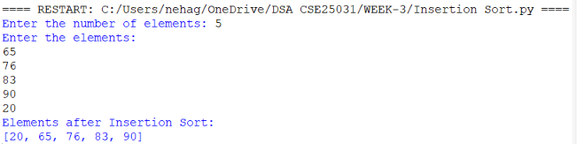
Explanation:
• n = len(arr) – Gets the list size.
• for i in range(1, n) – Selects elements from the second position.
• key = arr[i] – Stores the current element.
• j = i - 1 – Sets the previous index.
• while j >= 0 and arr[j] > key – Compares previous elements with key.
• arr[j + 1] = arr[j] – Shifts larger elements right.
• arr[j + 1] = key – Inserts key in the correct position.
• return arr – Returns the sorted list.
• result = insertion_sort(arr) – Calls the function.
• print(result) – Displays the sorted list.

ERROR TABLE:
S.NO | Error Obtained | Rectification
1. | Insertion Error – Placing key at the wrong index. | Use arr[j + 1] = key after shifting elements.
2. | Function Call Error – Not calling insertion_sort(arr) correctly. | Pass the input list arr to the function.

AIM: 3c.Write a python program to sort the elements using a selection sort technique. Take the input elements from the user.
Program:
def selection_sort(arr):
n=len(arr)
for i in range(n-1):
min_index=i
for j in range (i+1,n):
if arr[j]<arr[min_index]:
min_index=j
arr[i],arr[min_index]=arr[min_index],arr[i]
return arr
n=int(input("Enter the number of elements: "))
arr=[]
print("Enter the elements:")
for i in range(n):
element=int(input())
arr.append(element)
result=selection_sort(arr)
print("Elements after Selection Sort:")
print(result)
Output:
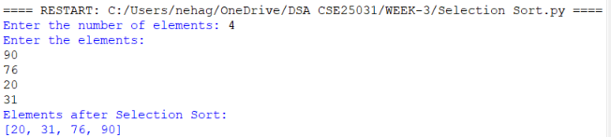
Explanation:
• def selection_sort(arr) – Defines the Selection Sort function.
• n = len(arr) – Gets the number of elements in arr.
• for i in range(n-1) – Performs sorting passes.
• min_index = i – Assumes the first element is the smallest.
• for j in range(i+1,n) – Checks the remaining elements.
• if arr[j] < arr[min_index] – Finds the smallest element.
• arr[i], arr[min_index] = ... – Swaps the smallest element into position.
• return arr – Returns the sorted list.
• result = selection_sort(arr) – Calls the function.
• print(result) – Displays the sorted list in ascending order.

Error Table:
S.NO | Error Obtained | Rectification
1. | Swap Error – Incorrectly swapping the elements. | Use arr[i], arr[min_index] = arr[min_index], arr[i].
2. | Minimum Index Error – Incorrectly assigning min_index. | Use min_index = i.

AIM: 3d.Write a python program to sort the elements using a merge sort technique. Take the input elements from the user.
Program:
def merge_sort(arr):
if len(arr) <= 1:
return arr
mid=len(arr)//2
left=merge_sort(arr[:mid])
right=merge_sort(arr[mid:])
i = j = k = 0
while i < len(left) and j < len(right):
if left[i] <= right[j]:
arr[k] = left[i]
i += 1
else:
arr[k] = right[j]
j += 1
k += 1
while i < len(left):
arr[k] = left[i]
i += 1
k += 1
while j < len(right):
arr[k] = right[j]
j += 1
k += 1
return arr
n = int(input("Enter the number of elements: "))
arr = []
print("Enter the elements:")
for i in range(n):
element = int(input())
arr.append(element)
result = merge_sort(arr)
print("Elements after Merge Sort:")
print(result)
Output:
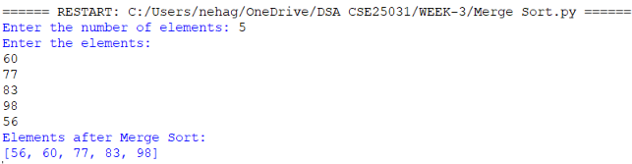
Explanation:
• def merge_sort(arr) – Defines the Merge Sort function.
• if len(arr) <= 1 – Stops when the list has one or no elements.
• mid = len(arr)//2 – Finds the middle of the list.
• left and right – Divide the list into two halves recursively.
• i = j = k = 0 – Initializes the indexes.
• while loops – Compare and merge the elements.
• if left[i] <= right[j] – Selects the smaller element.
• arr[k] – Places the selected element in the list.
Error Table:
S.NO | Error Obtained | Rectification
1. | Index Error – Incorrectly updating i, j, or k. | Increment the appropriate index after each insertion.
2. | Recursion Error – Incorrectly dividing the list. | Use arr[:mid] and arr[mid:].
AIM: 3e.Write a python program to sort the elements using a quick sort technique. Take the input elements from the user.
Program:
def quicksort(a,low,high):
if low < high:
i = low
j = high
pivot = low
while i < j:
while i < len(a) and a[i]<=a[pivot]:
i +=1
while a[j] > a[pivot]:
j = j -1
if i < j:
a[i],a[j] = a[j],a[i]
a[j],a[pivot] = a[pivot],a[j]
quicksort(a,low,j-1)
quicksort(a,j+1,high)
a = list(map(int,input("Enter numbers to sort:").split(" ")))
n = len(a)
quicksort(a,0,n-1)
print("Sorted array:")
print(a)
Output:
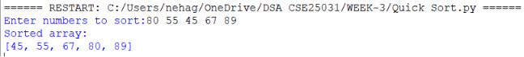

Explanation:
• def quicksort(a, low, high) – Defines the Quick Sort function.
• if low < high – Checks the sorting range.
• i and j – Set left and right positions.
• pivot = low – Selects the first element as pivot.
• while i < j – Performs partitioning.
• Inner while loops – Find elements for swapping.
• a[i], a[j] = ... – Swaps elements.
• a[j], a[pivot] = ... – Places the pivot correctly.
• quicksort() calls – Sort the two partitions.
• input().split() – Takes space-separated numbers.
• print(a) – Displays the sorted array.

Error Table:
S.NO | Error Obtained | Rectification
1. | Pivot Error – Incorrectly selecting the pivot index. | Use pivot = low.
2. | Swap Error – Incorrect swapping of a[i] and a[j]. | Use a[i], a[j] = a[j], a[i].

WEEK-4
AIM: 4a. Write the python program to implement a single linked list which could perform the below operations,by taking an input from the user.
Program:
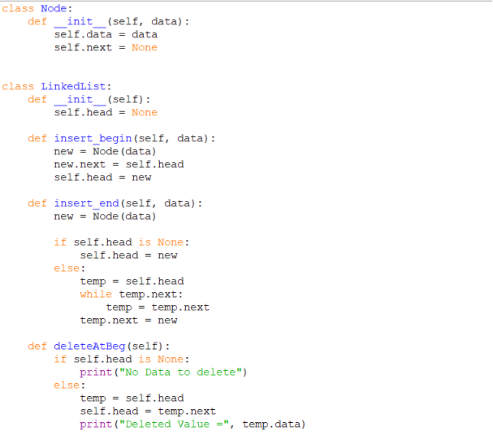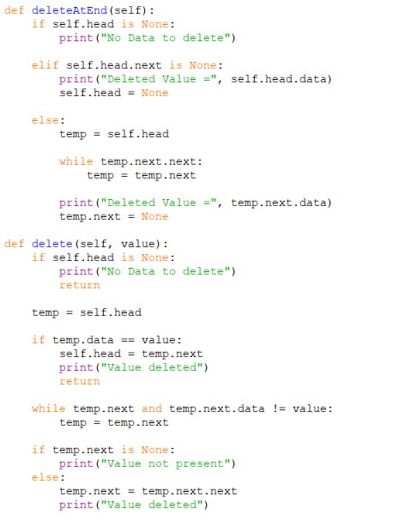
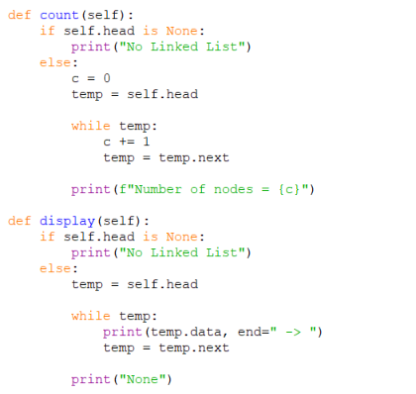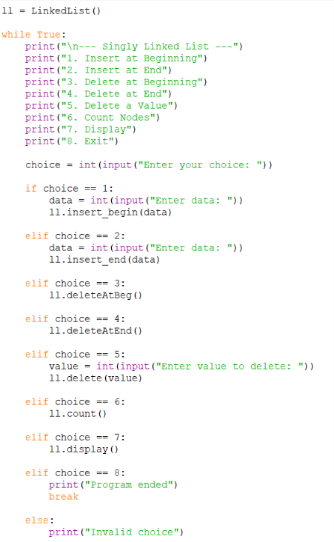
Output:
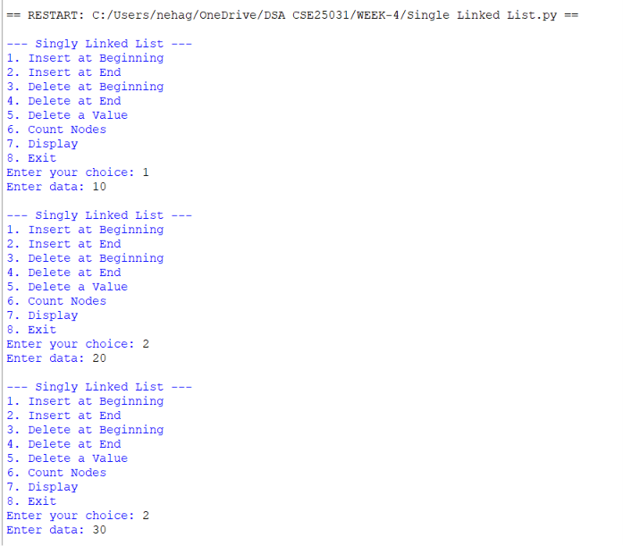
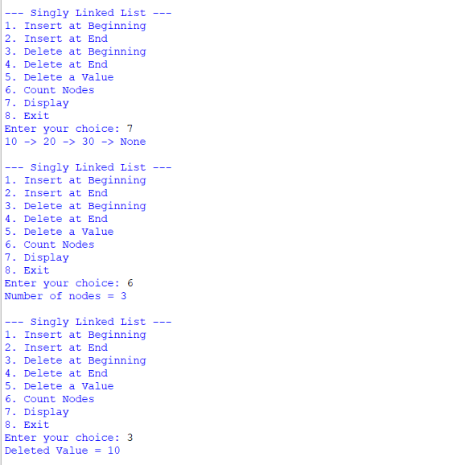

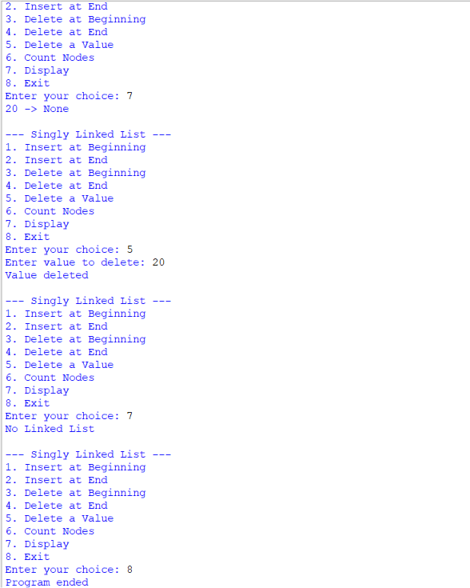

Explanation:
This program implements a Singly Linked List using Python. Each node contains two parts: data and a next pointer that stores the address of the next node.
- Node class: Creates a node with data and next.
- insert_begin(): Inserts a new node at the beginning of the linked list.
- insert_end(): Inserts a new node at the end of the linked list.
- deleteAtBeg(): Deletes the first node from the linked list.
- deleteAtEnd(): Deletes the last node from the linked list.
- delete(value): Searches for a given value and deletes that node.
- count(): Counts and displays the total number of nodes.
- display(): Displays all node values from beginning to end.
- Main program: Uses a menu so the user can select different linked-list operations until choosing Exit.

Error Table:
S.NO | Error Obtained | Rectification
1. | Error while deleting from an empty list | Check if self.head is None before deletion.
2. | Last node was not deleted correctly | Handle the single-node case and set the previous node's next to None.
3. | Incorrect output while displaying the list | Traverse using while temp: and print each node's data.

PROGRAM | TIME COMPLEXITY |  |  | SPACE COMPLEXITY | REASON
1. Insert at Beginning |  |  |  |  | Directly changes the head.
  O(1)
  O(1)
2.Insert at End |  |  |  |  | Traverse to the last node
  O(n)
  O(1)
3.Delete at Beginning |  |  |  |  | Directly removes the head
  O(1)
  O(1)
4.Delete at End |  |  |  |  | Traverse to the last node
  O(n)
  O(1)
5.Delete by value
  O(n)
  O(1)
  May search the entire list
6.Count Nodes | O(n) |  | O(1) |  | Traverses all nodes
7.Display |  | O(n) | O(1) |  | Traverse all nodes

AIM: 4b. Write the python program to implement a double linked list which could perform the below operations,by taking an input from the user.
Program:
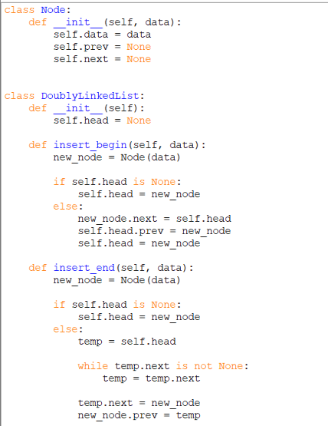
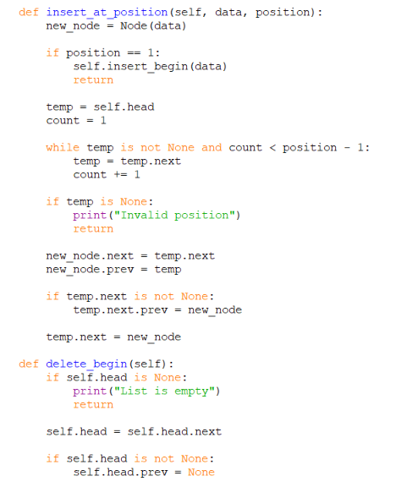
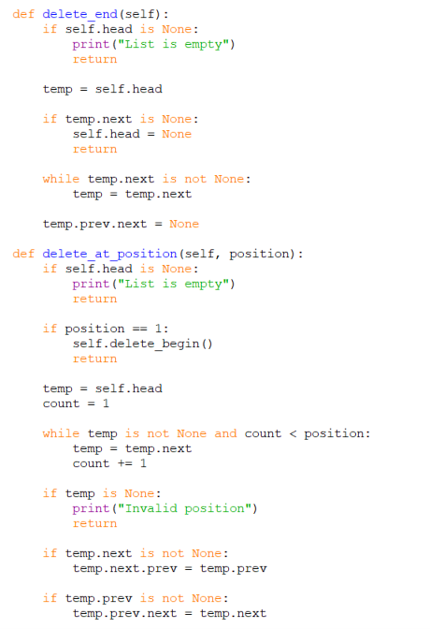
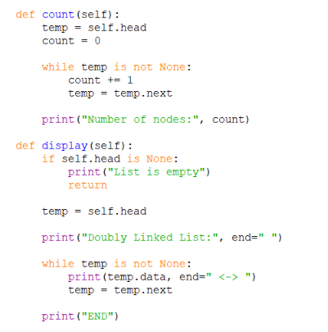

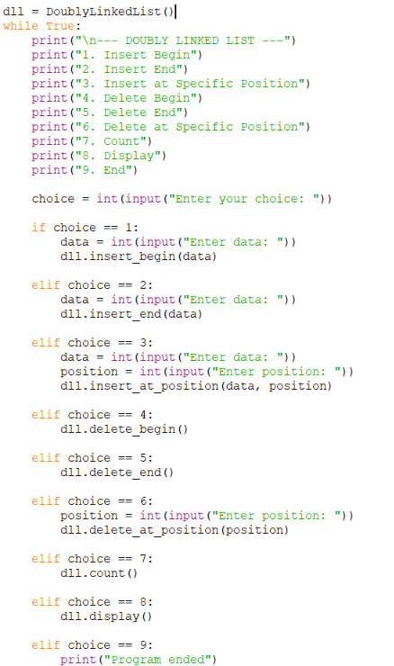

Output:
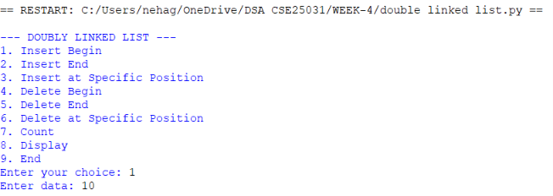

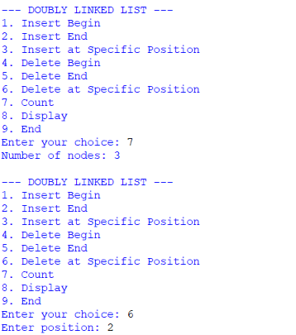
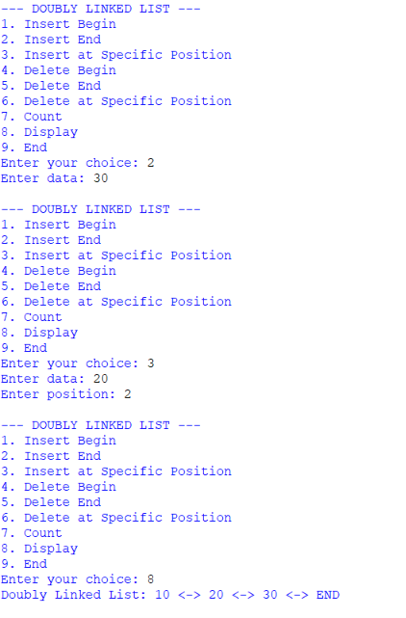

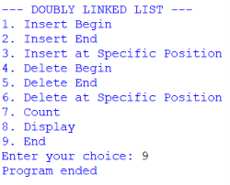
Explanation of Code:
A doubly linked list is a collection of nodes where each node contains data, previous link (prev) and next link (next). The program uses a menu to perform insertion, deletion, counting, and display operations.
- Node: Stores data, prev, and next.
- Head: Points to the first node of the list.
- Insert Begin: Adds a new node at the beginning and updates the links.
- Insert End: Traverses to the last node and adds the new node.
- Insert at Position: Adds a node at the specified position by updating both links.
- Delete Begin: Removes the first node and changes the head.
- Delete End: Removes the last node and sets the previous node's next to None.
- Delete at Position: Removes the specified node and connects its previous and next nodes.
- Count: Traverses the list and counts the number of nodes.
- Display: Traverses and prints all node values.
- End: Stops the program using break.
Error Table:
S.NO | Error Obtained | Rectification
1. | Forgetting to update prev and next links. | Update both links correctly during insertion and deletion.
2. | Deleting a node from an empty list. | Check if self.head is None before deletion.
3. | Entering an invalid position. | Check the position and display “Invalid position”.

PROGRAM | TIME COMPLEXITY |  |  | SPACE COMPLEXITY | REASON
1. Insert at Beginning |  |  |  |  | Directly inserts before head
  O(1)
  O(1)
2.Insert at End |  |  |  |  | Traverse the list to reach the last node.
  O(n)
  O(1)
3.Delete at Beginning |  |  |  |  | Directly removes the first node
  O(1)
  O(1)
4.Delete at End |  |  |  |  | Traverse to the last node
  O(n)
  O(1)
5.Delete by value
  O(n)
  O(1)
  Traverses to the specified position
6.Count Nodes | O(n) |  | O(1) |  | Visits every node to count them
7.Display |  | O(n) | O(1) |  | Visits every node to display the data

AIM: 4c. Write the python program to implement a circular linked list which could perform the below operations,by taking an input from the user.
Program:
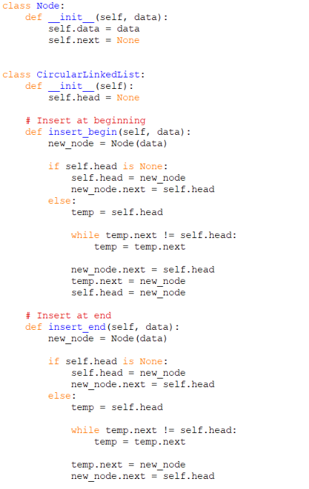
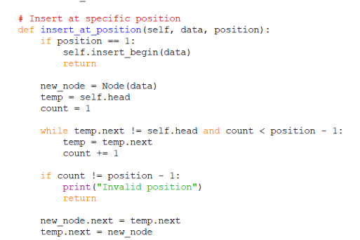
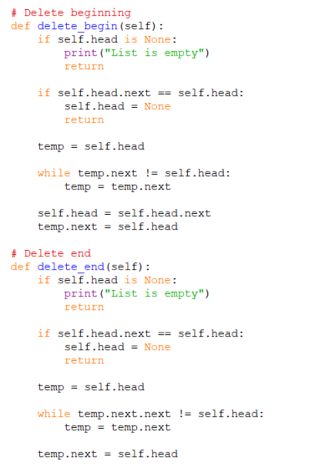
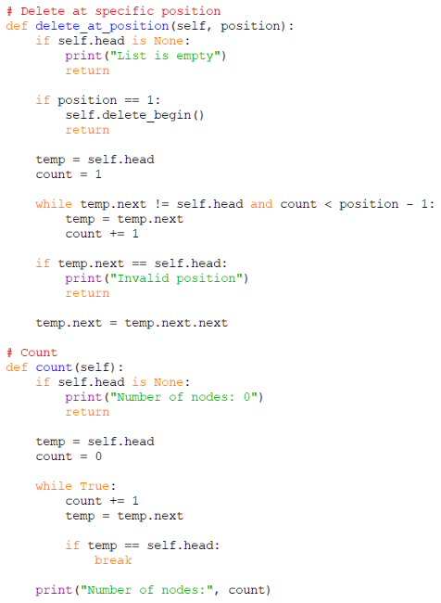
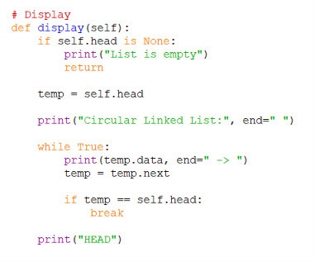
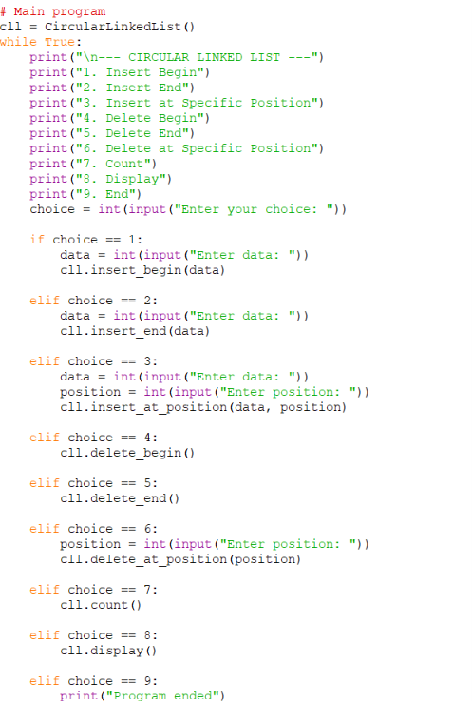

Output:
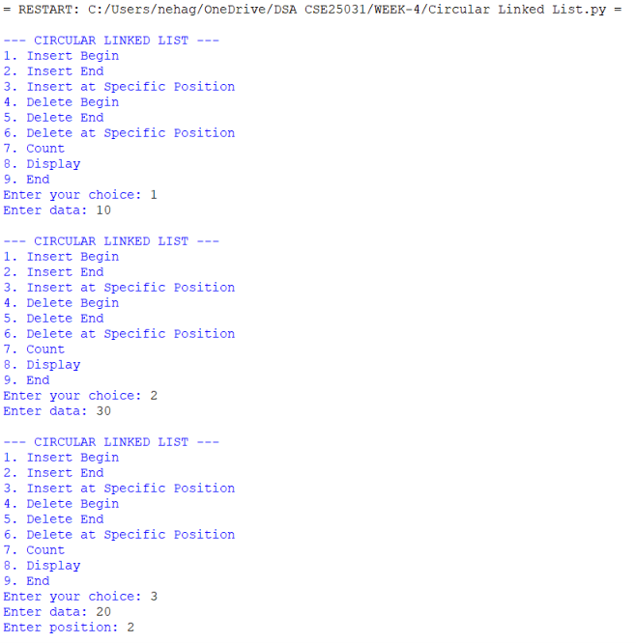
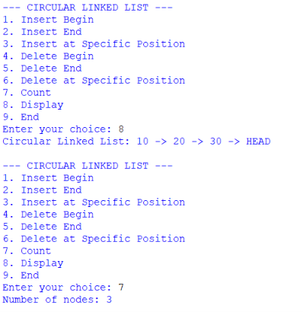
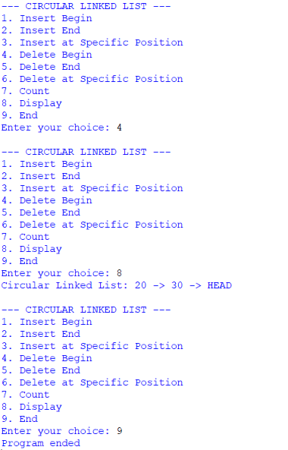
Explanation Of Codes:
A circular linked list is a linked list where the last node points back to the first node (head).
- Node: Stores data and next.
- Head: Points to the first node.
- Insert Begin: Adds a node before the current head.
- Insert End: Adds a node after the last node.
- Insert Position: Inserts a node at the given position.
- Delete Begin: Removes the first node and updates head.
- Delete End: Removes the last node.
- Delete Position: Removes a node from the specified position.
- Count: Counts all nodes by traversing the list.
- Display: Displays nodes until it reaches head again.
- End: Stops the program using break.

Error Table:
S.NO | Error Obtained | Rectification
1. | Forgetting to connect the last node to head. | Set the last nodes’s next = head.
2. | Deleting from an empty list | Check if self.head is None before deletion.
3. | Infinite loop during traversal. | Stop traversal when temp = = self.head.

PROGRAM | TIME COMPLEXITY |  |  | SPACE COMPLEXITY | REASON
1. Insert at Beginning |  |  |  |  | Finds the last node to update its link.
  O(n)
  O(1)
2.Insert at End |  |  |  |  | Traverse to the last node.
  O(n)
  O(1)
3.Delete at Beginning |  |  |  |  | Finds the last node.
  O(n)
  O(1)
4.Delete at End |  |  |  |  | Traverse to the second-last node
  O(n)
  O(1)
5.Delete by value
  O(n)
  O(1)
  Traverses to the specified position
6.Count Nodes | O(n) |  | O(1) |  | Visits every node
7.Display |  | O(n) | O(1) |  | Visits every node

WEEK-5

AIM:5a. Write a python program to implement a stack using an Array, Linked list. Implement the stack operations such as push, pop, peak and also display the stack elements.
Program:
Stack Using Array:
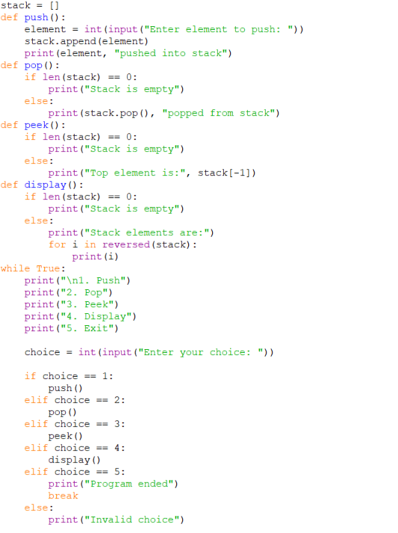

Output:
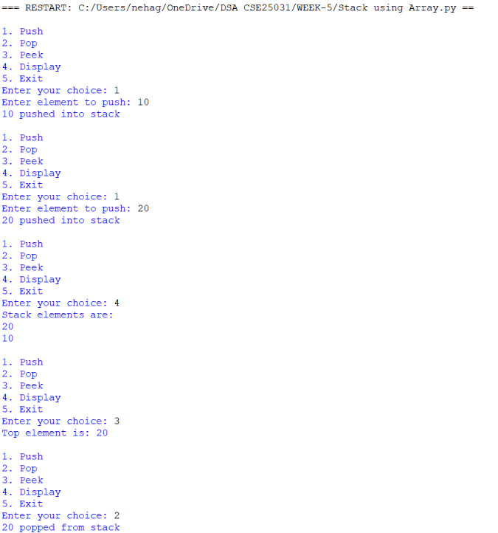
Error Table:
S.NO | Error Obtained | Rectification
1. | Trying to access stack[-1] when empty | Check whether stack is empty
2. | IndexError: pop from empty list - Trying to pop when stack is empty | Check len(stack) == 0 before pop
3. | Wrong display order - Elements displayed from bottom to top | Use reversed(stack)

Explanation Of Code:
stack = [] creates an empty list to store stack elements.
Push: append() adds a new element to the top of the stack.
Pop: pop() removes the top element from the stack.
Peek: stack[-1] displays the top element without removing it.
Display: reversed(stack) displays elements from top to bottom.
Empty check: len(stack) == 0 checks whether the stack is empty.
Menu: The while loop repeatedly displays the operations until the user selects Exit.

Stack Using Linked List:
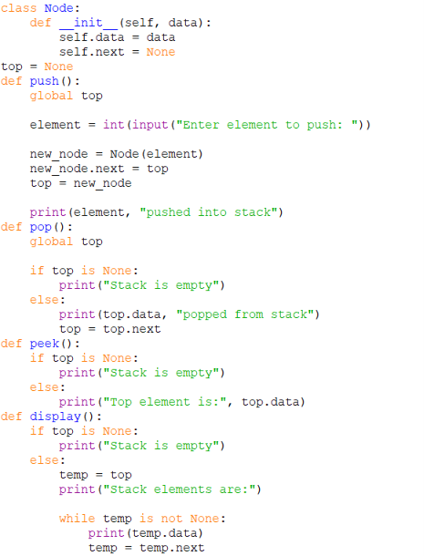
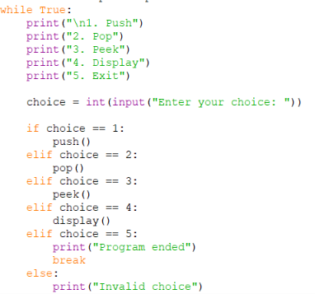
Output:
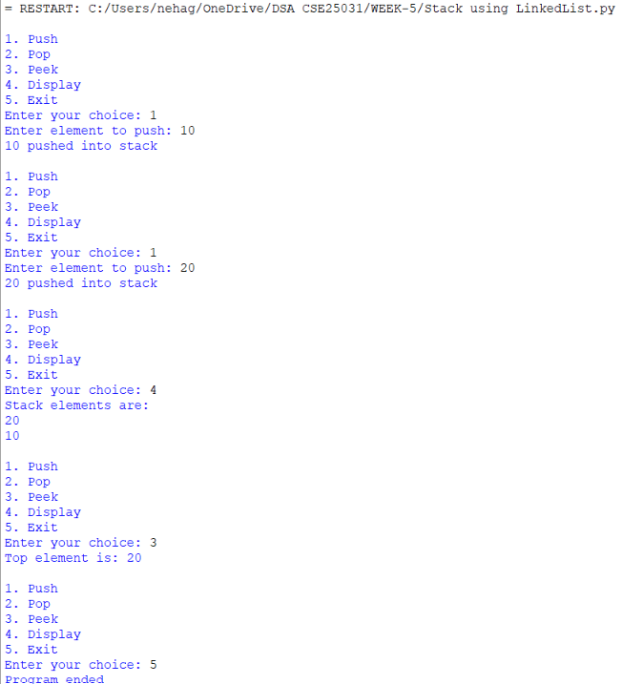
Error Table:
S.NO | Error Obtained | Rectification
1. | AttributeError - Accessing top.data when top is None | Check top is None
2. | Pop does not work - top is not updated | Use top = top.next
3. | Display gives wrong result - Temporary pointer is not moved | Use temp = temp.next

Explanation of Code:
Node class creates a node containing data and a next pointer.
top = None indicates that the stack is initially empty.
Push: A new node is created and connected before the current top. The new node becomes top.
Pop: The top node is removed by making top = top.next.
Peek: top.data displays the top element without removing it.
Display: A temporary pointer temp traverses the linked list and displays every element.
Empty check: top is None checks whether the stack contains any elements.
Menu: The while loop allows the user to repeatedly perform stack operations.

WEEK – 6
6a. AIM: Write a python program to implement queue and its operations such as enqueue, dequeue, peek, display with a menu driven approach implement using array, linked list.
PROGRAM: Using array
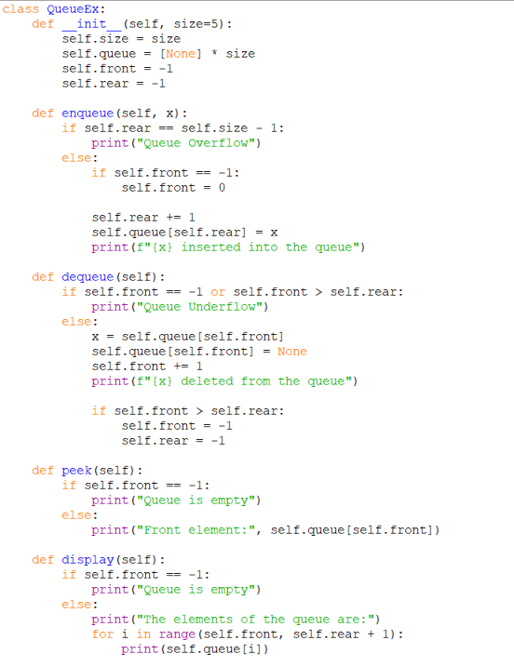

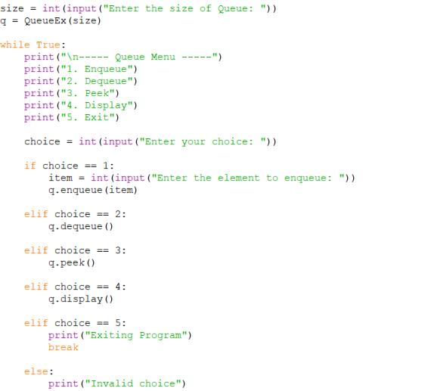

Output:
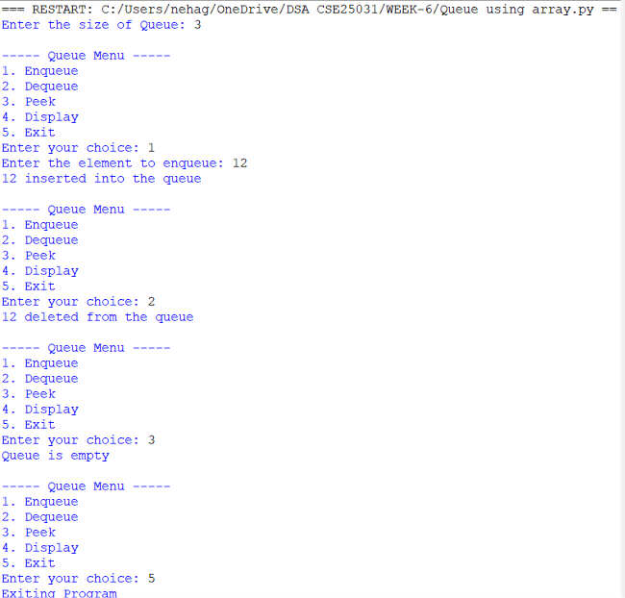
PROGRAM: Using Linked list
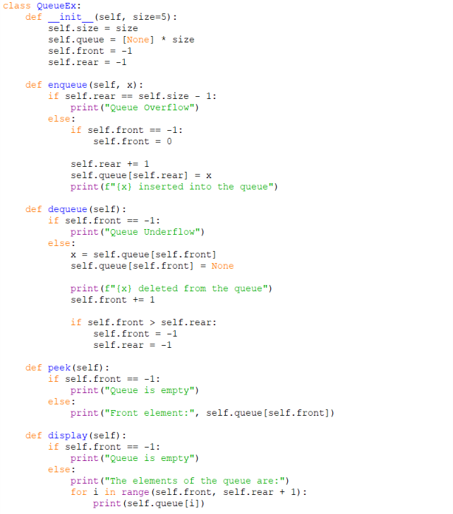
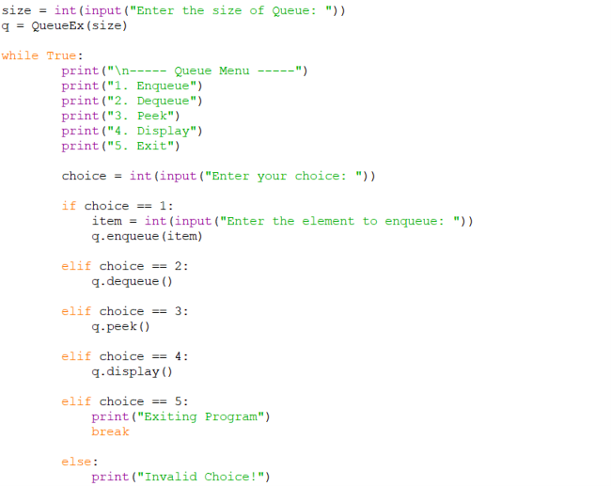
Output:

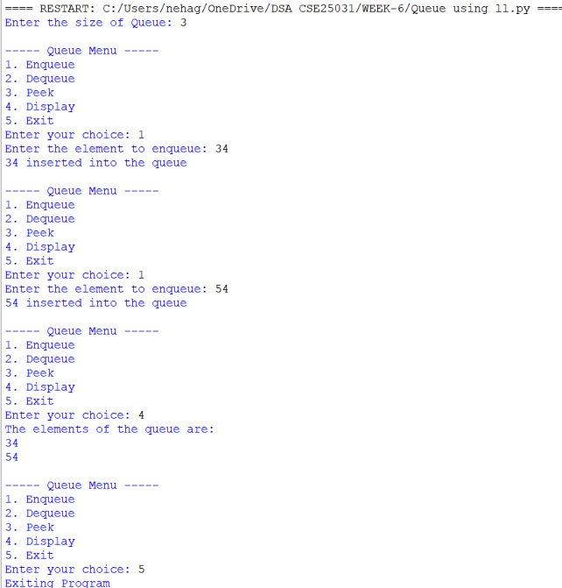

Explanation:
· class QueueEx: Creates a class named QueueEx for implementing the queue.
· __init__(self, size=5): Constructor that initializes the queue with a default size of 5.
· self.size = size : Stores the user-given queue size.
· self.queue = [None] * size : Creates a list of the given size and initializes all positions with None.
· self.front = -1 : Initializes front to indicate that the queue is empty.
· self.rear = -1 : Initializes rear to indicate that no element is present.
enqueue()
· if self.rear == self.size - 1: Checks whether rear has reached the last position.
· self.front = 0 : Sets the front position when inserting the first element.
· self.rear += 1 : Increases rear to the next position.
· self.queue[self.rear] = x : Stores x at the rear position.
· print() : Displays the insertion message.
dequeue()
· if self.front == -1 or self.front > self.rear: Checks whether the queue is empty.
· x = self.queue[self.front] : Stores the front element in x.
· self.queue[self.front] = None : Removes the front element from the list.
· self.front += 1 : Moves front to the next position.
· if self.front > self.rear: : Checks whether all elements have been deleted.
· self.front = -1 and self.rear = -1 : Resets the queue to the empty state.
peek()
· if self.front == -1: Checks whether the queue is empty.
· self.queue[self.front] : Accesses and displays the front element without deleting it.
display()
· if self.front == -1: Checks whether the queue is empty.
· range(self.front, self.rear + 1) : Traverses the queue from front to rear.
· print(self.queue[i]) : Displays each queue element.

Error Table:
S.NO | Error Obtained | Rectification
1. | Queue Overflow occurs when the queue is full. | Check if self.rear == self.size - 1 before inserting an element.
2. | Queue Underflow occurs when the queue is empty. | Check if self.front == -1 or self.front > self.rear before deleting an element.

6b. AIM: Write a python program to implement queue and its operations such as enqueue, dequeue, peek, display with a menu driven approach implement using circular linked list.
Program:
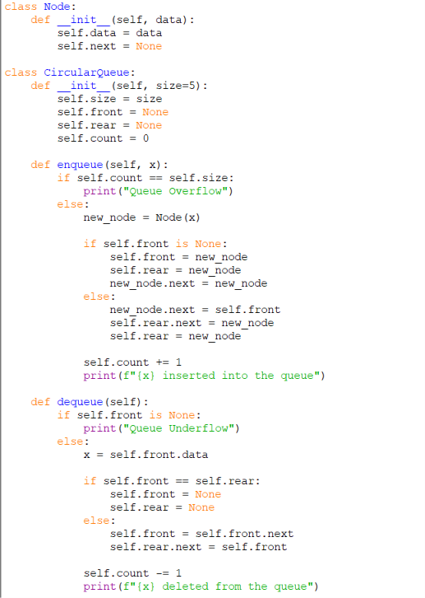
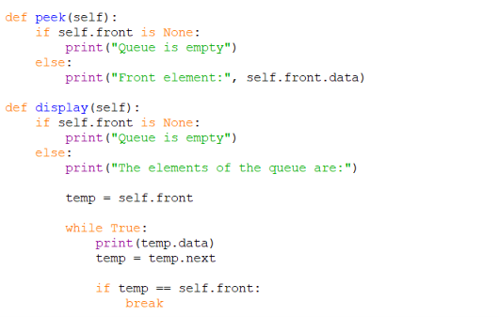
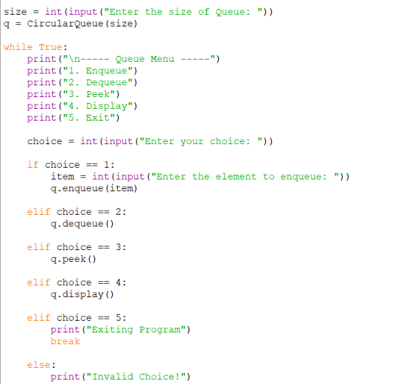

Output:
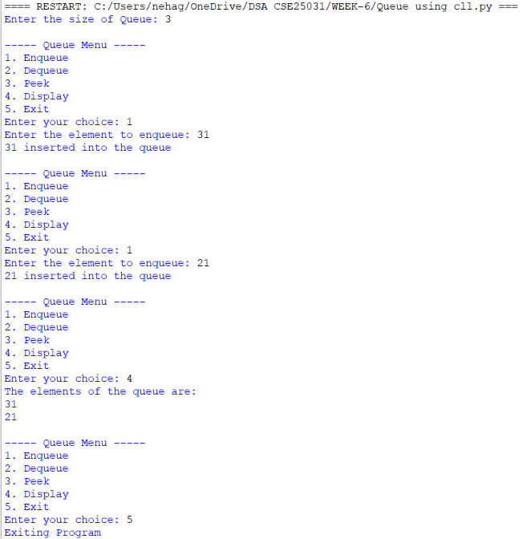
Explanation:
1.Node Linking
- self.next = None : Initializes the node link as empty.
- new_node = Node(x) : Creates a new node with the given data.
- new_node.next = new_node : Makes the first node point to itself, forming a circular link.
2.Circular Connection During Enqueue
- new_node.next = self.front : Connects the new node to the first node.
- self.rear.next = new_node : Connects the current last node to the new node.
- self.rear = new_node : Updates the last node to the newly inserted node.
3. Circular Connection During Dequeue
- self.front = self.front.next : Moves front to the next node.
- self.rear.next = self.front : Reconnects the last node to the new front node.
- if self.front == self.rear: : Checks whether only one node exists.
- self.front = None : Removes the only node by clearing the front reference.
- self.rear = None : Clears the rear reference.
4. Circular Traversal
- temp = self.front : Starts traversal from the first node.
- temp = temp.next : Moves to the next linked node.
- if temp == self.front: : Detects that traversal has returned to the first node.
- break : Stops traversal after one complete circular cycle.
5. Node Data Access
- self.front.data : Accesses the data stored in the front node.
- temp.data : Accesses the data of the current node during traversal.

Error Table:
S.NO | Error Obtained | Rectification
1. | new_node.next is not connected to front, breaking the circular link. | Set new_node.next = self.front.
2. | self.rear.next is not updated after insertion or deletion. | Update self.rear.next = new_node during enqueue and self.rear.next = self.front during dequeue.

WEEK-7
AIM: 7. Write a program to implement a binary tree using an array and linked list with all of its operation.
Program:
Binary Tree Using An Array:
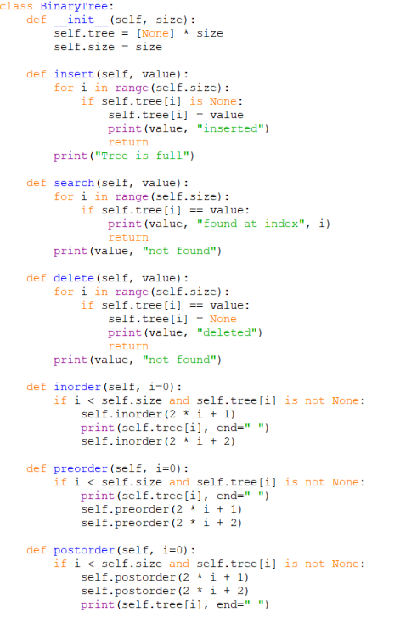
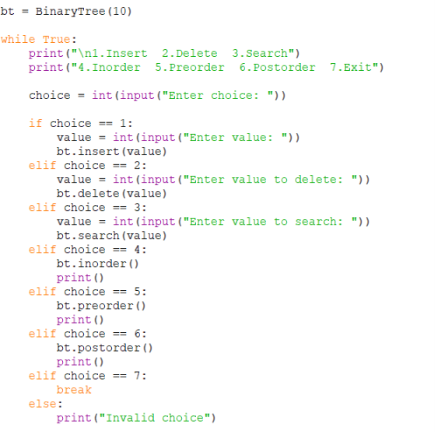
Output:
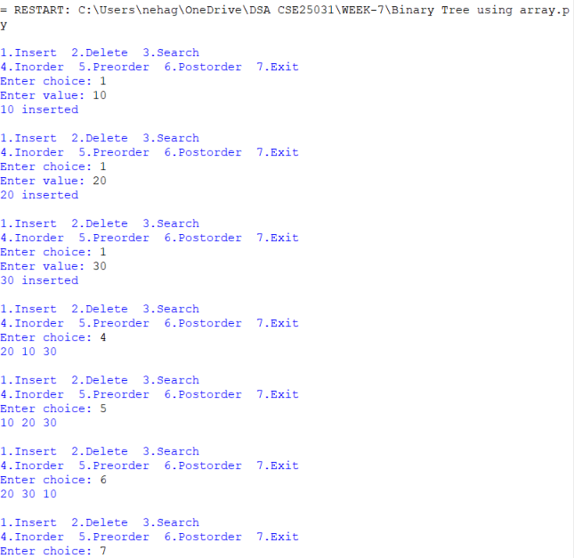
Explanation of Code:
1. Initialization
- class BinaryTree: Creates a binary tree class.
- __init__(self, size): Initializes the tree.
- self.tree = [None] * size: Creates an empty array.
- self.size = size: Stores the maximum size of the array.
2. Insertion
- insert(self, value): Inserts a value into the tree.
- The for loop checks each array position.
- if self.tree[i] is None: Checks whether the position is empty.
- self.tree[i] = value: Stores the value.
- return: Stops the function after insertion.
- If no empty position exists, it displays Tree is full.
3. Searching
- search(self, value): Searches for a value.
- The for loop checks each array element.
- self.tree[i] == value: Compares the element with the search value.
- If found, it displays the value and its index.
- Otherwise, it displays not found.
4. Deletion
- delete(self, value): Deletes a value from the tree.
- The for loop searches for the value.
- self.tree[i] = None: Removes the value from that position.
- If the value is not found, it displays not found.
5. Inorder Traversal
- inorder(self, i=0): Traverses the tree in inorder.
- Order: Left → Root → Right
- 2*i + 1: Finds the left child.
- 2*i + 2: Finds the right child.
- Prints the root between the left and right subtrees.
6. Preorder Traversal
- preorder(self, i=0): Traverses the tree in preorder.
- Order: Root → Left → Right
- Prints the root first.
- Visits the left subtree.
- Visits the right subtree.
7. Postorder Traversal
- postorder(self, i=0): Traverses the tree in postorder.
- Order: Left → Right → Root
- Visits the left subtree.
- Visits the right subtree.
Error Table:
S.NO | Error Obtained | Rectification
1. | Attribute Error- Accessing a node that is None. | Check whether the node exists before accessing its attribute.
2. | Tree is full- The array has no empty positions | Increase the array size
3. | Incorrect traversal output- Using the wrong traversal order or child indexes | Verify the traversal order and child indexes.

Binary Tree Using Linked List:
Program:
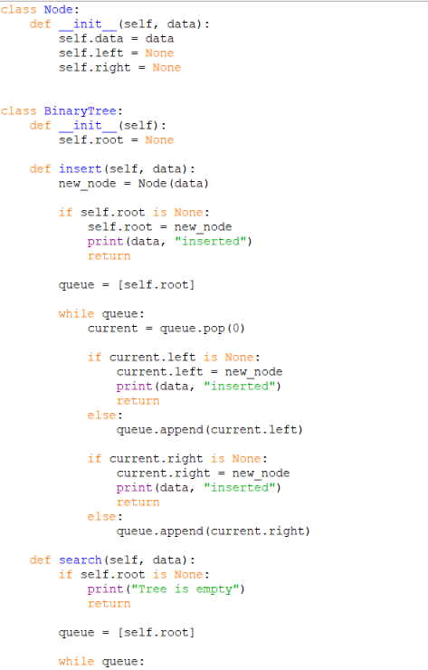
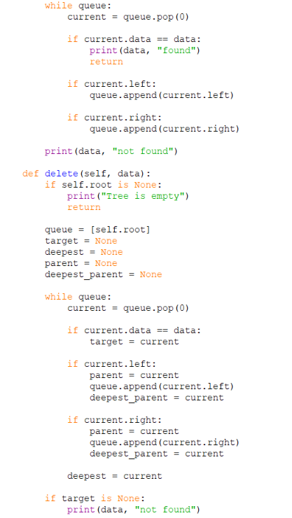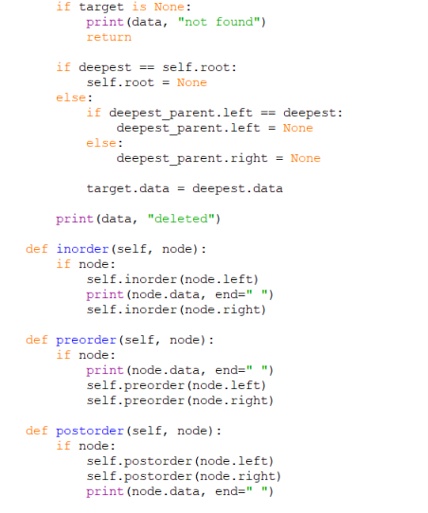
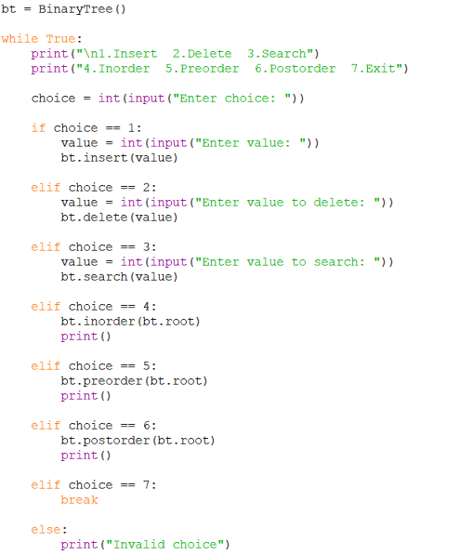
Output:
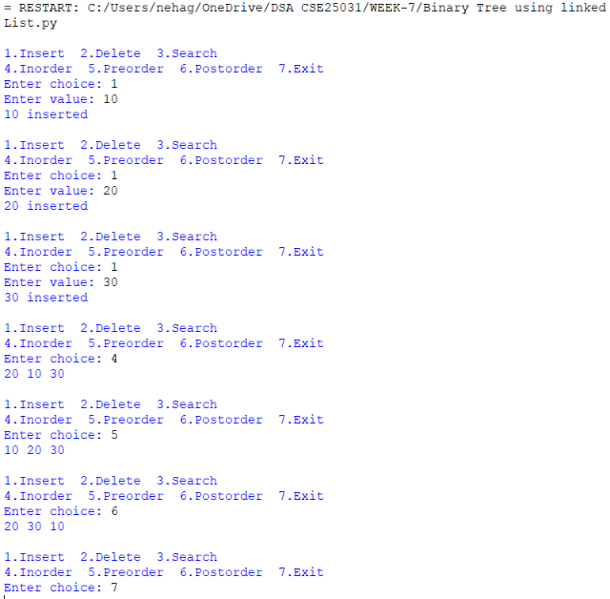
Explanation Of Code:
1. Node Creation
- class Node: Creates a node class.
- self.data = data: Stores the node's value.
- self.left = None: Initializes the left child.
- self.right = None: Initializes the right child.
2. Tree Initialization
- class BinaryTree: Creates the binary tree class.
- __init__(self): Initializes the tree.
- self.root = None: Indicates that the tree is initially empty.
3. Insertion
- insert(self, data): Inserts a new node.
- Node(data): Creates a new node.
- if self.root is None: Checks whether the tree is empty.
- If empty, the new node becomes the root.
- queue = [self.root]: Creates a queue containing the root.
- queue.pop(0): Removes the first node from the queue.
- current.left is None: Checks whether the left child is empty.
- current.right is None: Checks whether the right child is empty.
- Inserts the new node at the first available position.
4. Searching
- search(self, data): Searches for a value.
- Checks whether the tree is empty.
- Creates a queue starting with the root.
- Checks each node's data.
- Adds existing left and right children to the queue.
- Displays found if the value exists.
- Otherwise, displays not found.
5. Deletion
- delete(self, data): Deletes a node.
- Checks whether the tree is empty.
- Finds the node containing the target value.
- Finds the deepest, rightmost node.
- Copies the deepest node's value into the target node.
- Removes the deepest node from its parent.
- If the root is the only node, sets self.root = None.
6. Inorder Traversal
- inorder(self, node): Traverses the tree in inorder.
- Order: Left → Root → Right
- Visits the left child.
- Prints the current node.
- Visits the right child.
7. Preorder Traversal
- preorder(self, node): Traverses the tree in preorder.
- Order: Root → Left → Right
- Prints the current node first.
- Visits the left child.
- Visits the right child.

Error Table:
S.NO | Error Obtained | Rectification
1. | Type Error- Using an invalid data Type. | Convert input using int( )
2. | Value not found- Searching for a value that does not exist. | Enter an existing value.
3. | Tree is full- The array has no empty positions | Increase the array size.

WEEK-8

AIM: 8.Write a python program to implement Binary Search Trees with its operations.
Program:
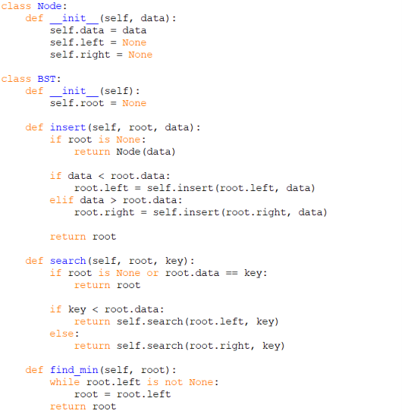
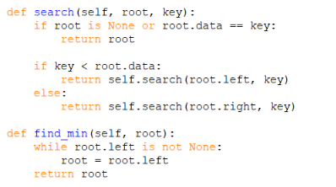
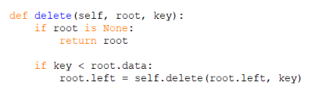
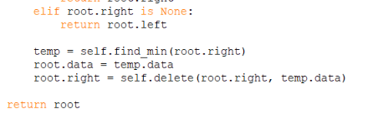
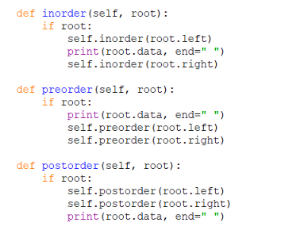
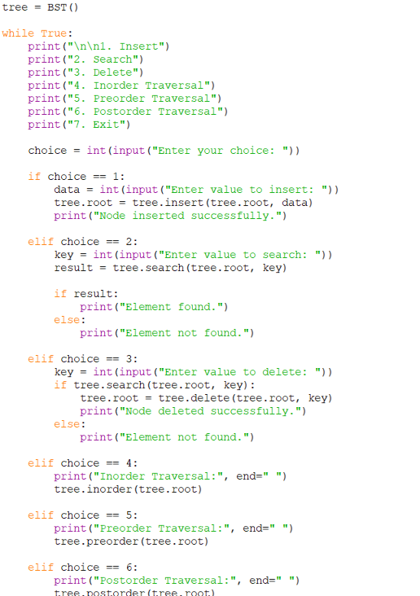
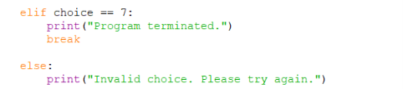
Output:
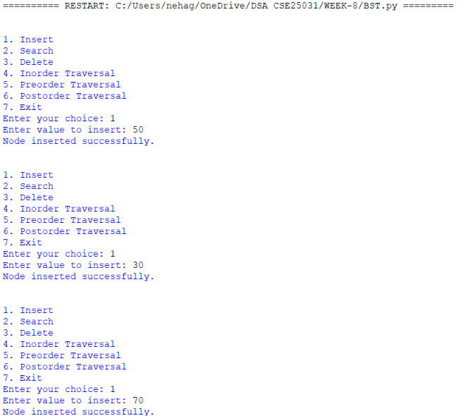
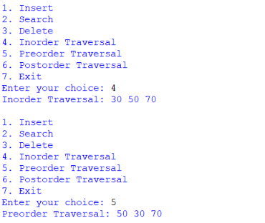

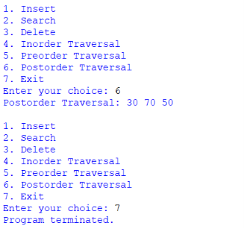
Explanation Of Code:
- Node Class: Creates a node with data, left child, and right child.
- BST Class: Creates a Binary Search Tree with the root initially set to None.
- Insertion: The insert() function adds a new node in the correct position. Smaller values go to the left, and greater values go to the right.
- Searching: The search() function checks whether the given element exists in the tree.
- Finding Minimum: The find_min() function finds the smallest value by moving towards the leftmost node.
- Deletion: The delete() function removes a node while maintaining the BST properties. It handles nodes with no children, one child, or two children.
- Inorder Traversal: The inorder() function visits the left subtree, root, and right subtree. It displays the values in ascending order.
- Preorder Traversal: The preorder() function visits the root, left subtree, and right subtree.
- Postorder Traversal: The postorder() function visits the left subtree, right subtree, and root.
- Main Program: Creates a BST object and displays a menu for insertion, searching, deletion, traversals, and exit.
- While Loop: Repeats the menu until the user chooses the exit option.

Error Table:
S.NO | Error Obtained | Rectification
1. | ValueError – Entering a non-integer value when an integer is expected | Enter a valid integer.
2. | RecursionError – Excessive calls for a deeply unbalanced tree. | Use an iterative approach or a balanced BST.
3. | Duplicate values ignored – The insertion method does not insert duplicate values. | Enter a unique value.

Time Complexity:
Operation | Average Case | Woest Case
Insertion | O(log n) | O(n)
Searching | O(log n) | O(n)
Traversal | O(n) | O(n)
Deletion | O(log n) | O(n)

WEEK-9

AIM: 9. Write a python program to implement AVL trees with its operation.
Program:
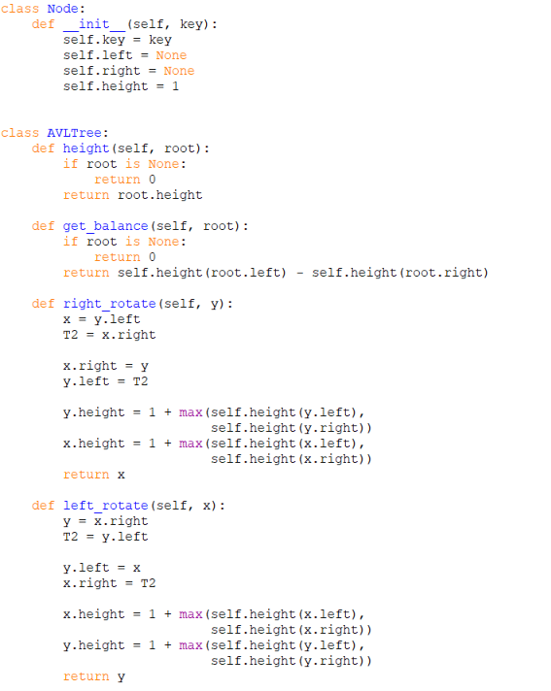
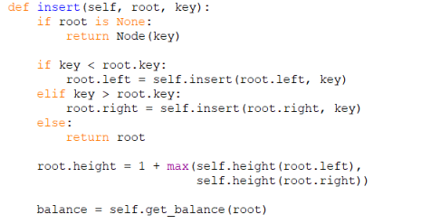
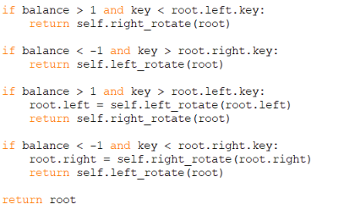
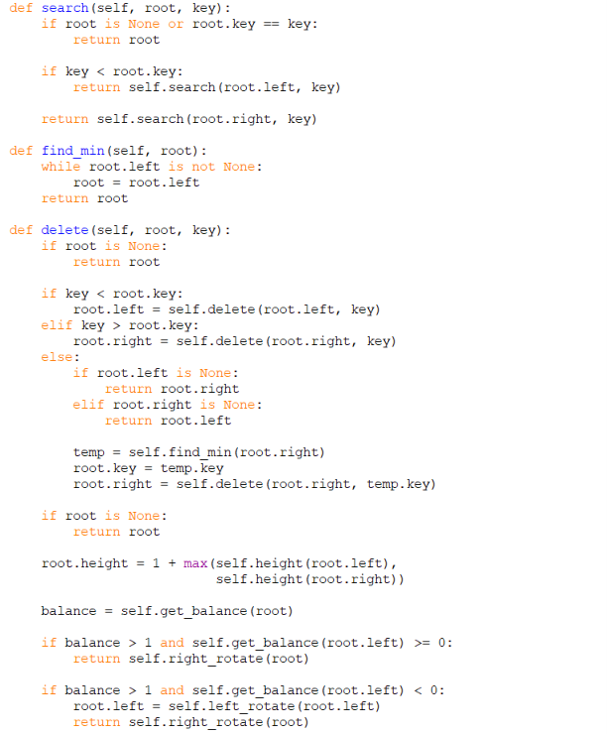
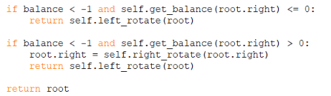
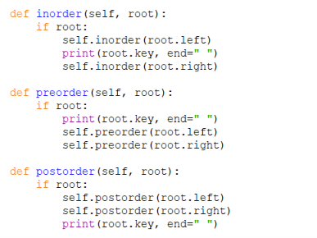
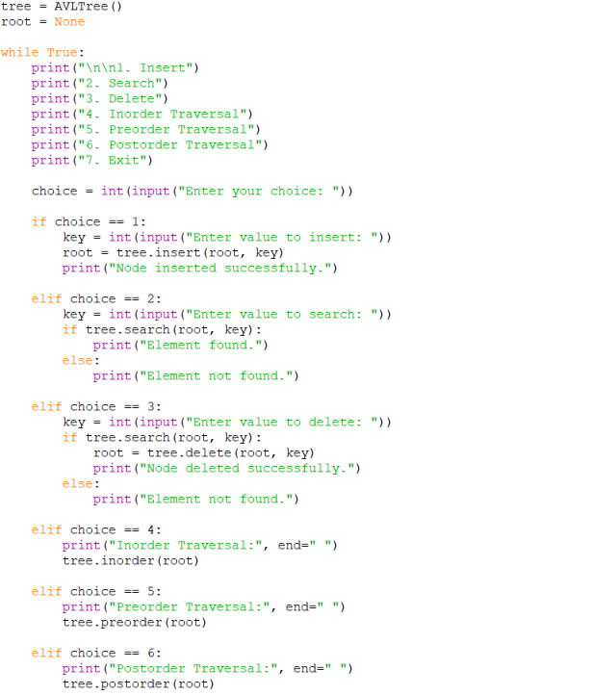
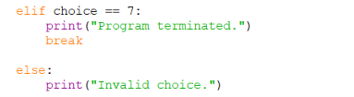
Output:
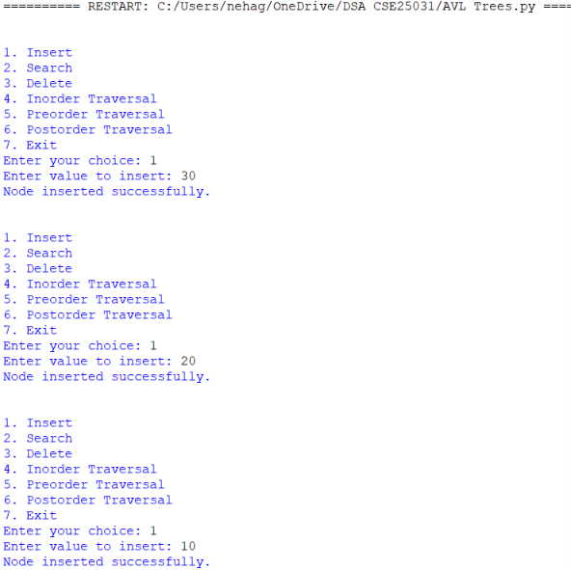
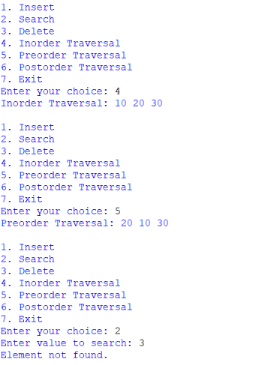

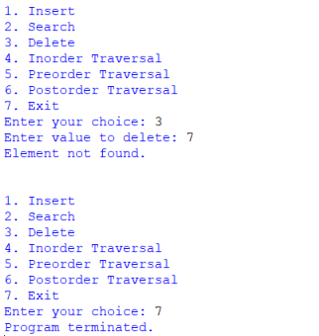
Explanation Of Code:
- Node Class: Creates a node containing a key, left child, right child, and height.
- Height: Returns the height of a node.
- Balance Factor: Calculates the difference between the heights of the left and right subtrees.
- Right Rotation: Balances a tree when the left side becomes too heavy.
- Left Rotation: Balances a tree when the right side becomes too heavy.
- Insertion: Inserts a new value and balances the tree if necessary.
- Searching: Finds whether a given value exists in the tree.
- Finding Minimum: Finds the smallest value in a subtree.
- Deletion: Removes a node and restores the AVL balance.
- Inorder Traversal: Visits Left → Root → Right and displays values in ascending order.
- Preorder Traversal: Visits Root → Left → Right.
- Postorder Traversal: Visits Left → Right → Root.
- Main Program: Displays a menu to perform operations until the user chooses Exit.

Four Rotation Cases:
Case | Condition | Rotation
LL(Left-Left) | Left subtree becomes too heavy on its left side | Right rotation
RR(Right-Right) | Right subtree becomes too heavy on its right side | Left Rotation
LR(Left-Right) | Left subtree becomes too heavy on its right side | Left rotation, then right rotation
RL(Right-Left) | Right subtree becomes too heavy on its left side | Right rotation, then left rotation

Error Table:
S.NO | Error Obtained | Rectification
1. | ValueError – Entering a non-integer | Enter a valid integer.
2. | AttributeError – Accessing a property of None | Check whether the node exists
3. | Element not found – Value does not exist in the tree | Enter an existing value.

Time Complexity:
Operation | Time Complexity
Insertion | O(log n)
Searching | O(log n)
Traversal | O(n)
Deletion | O(log n)
Rotation | O(1)

